University College of Engineering Science and Technology

Lahore Leads University



Project Report:

**Hydraulics Machinery**

Subject:

**Parachut Project**

Submitted To:

**Engr. Abdul Haadi**

Submitted By:

**Imtisal Ahmad**

Reg NO:

**11-MT-791**

Date:

**27 -01-2014**

**Acknowledgement:**

**Dedicated to my beloved**

**Teachers & Parents**

**Who showed me the path to light.**

**Who teach me how to walk on the**

**Road of Success…**

**CONTENTS:**

1. **Project introduction**
2. **Basic idea**
3. **Research**
4. **My design**
5. **Technical aspects**
6. **Layout**
7. **Physical Evidence**
8. **Conclusion(1) PROJECT INTRODUCTION :**

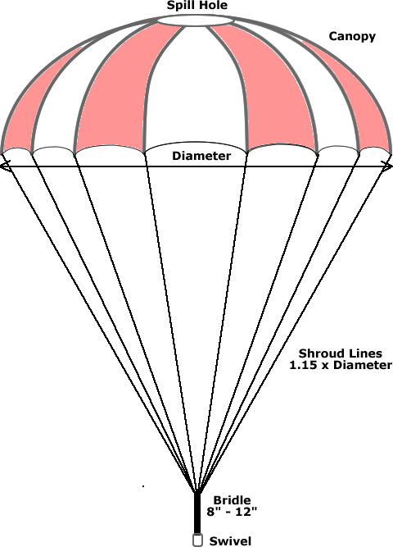

**The topic chosen for project is “Parachuting” and most of the necessary physics equations associated with parachuting are given below together with their derivations.**

**I have to utilize its existing and newly acquired knowledge to produce an appropriate model (equations + tables + charts) showing how parachutes enable people to jump safely from an aircraft.**

**I have explained the physical principles involved and produce Excel graphs of altitude and velocity throughout group discussions, group report and individual presentations.**

**(2) Basic Idea:**

**To determine what shape parachute (circle, square, rectangle, triangle or ellipse) will slow your fall down the best. I hypothesize that the circle shaped parachute will fall the slowest because there are no sharp angles or straight edges in the shape.**

**(3) RESEARCH:**

**I did a quick internet search using Google for information about generic parachute design that I could apply to a winch parachute. I found that there wasn't too much relevant non-commercial information available. The best site I found that answered most of the questions I had was Richard Nakka's Experimental Rocketry Site which has a detailed page on parachute performance parameters and some formulae. The site is oriented towards model rocketry and the parachute page describes a large 1m diameter 12 gore parachute designed for high speed deployment in the recovery of a model rocket.**

**It can be found at** http://members.aol.com/ricnakk/paracon.html

***A Hemispherical Parachute Canopy***

**A more efficient and proper parachute is one where the deployed canopy takes on the shape of a hemisphere. To form a parachute that deploys as a hemisphere, it is necessary to take the desired three dimensional hemispherical shape and divide it into a number of two dimensional panels, called gores. Each gore is individually cut to a specific shape so that when re-assembled it will form a hemisphere upon deployment.**

**To enable me to be able to create plots for different sizes of parachute, with a different number of gores I developed an Excel spreadsheet to do all the numerical calculations. I simply change some parameters such as the number of gores, base diameter and elliptical ratio (more on that later) and the appropriate plots are produced. For example –**

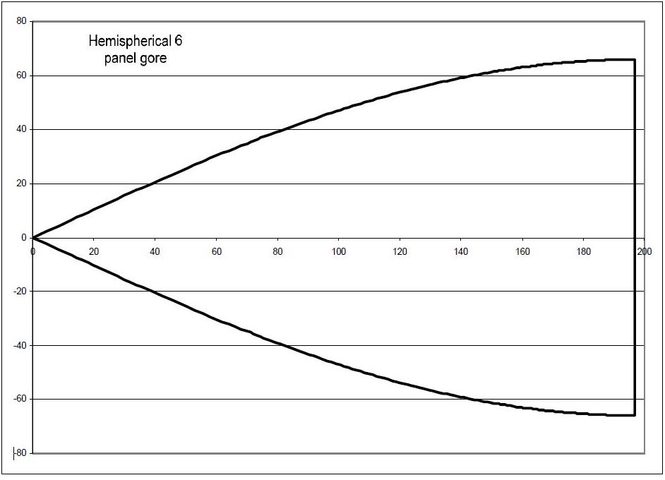 **Diagram 1** - Gore pattern for 6 gore 252mm dia hemispherical parachute

**The diagram above shows a single gore panel for a six panel hemispherical parachute canopy that is 252mm in diameter at the base and 126mm high. Six of these gore panels need to be made and assembled to form the parachute.**

**An interesting point to note is that the angle subtended on the left hand side of the pattern is 60 degrees (1/6 of 360 degrees) so that when all six gores are joined they complete the 360 degree circle. Also note that the two edges of the gore at the right hand side are parallel. These two edges are at the lower perimeter of the hemisphere and the lines here will be vertical on the resultant hemispherical canopy.**

**The parachute canopy that results will still not be quite a perfect hemisphere since it comprises a relatively small number of two dimensional gores. A closer to perfect result can be achieved by constructing a parachute with more gores. However more gores equals more sewing for assembly and for winch/bungee purposes true perfection in the parachute canopy profile is not absolutely required.**

**To minimise the number of gores to be joined it is possible to make a canopy with only four panels, but with fewer panels the final canopy shape will deviate more and more from the ideal shape. The shape of each gore will be different to the one shown above.**

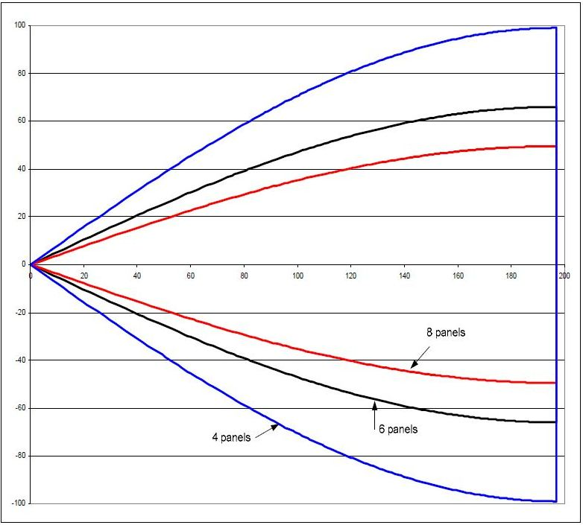 **Diagram 2 -** Comparison of 4 gore, 6 gore and 8 gore panels

**The relative size difference of each gore for a four gore, six gore and an eight gore hemispherical parachute are shown for comparison in the diagram above. The parachute diameter is 252mm for all cases. Hemispherical parachutes actually use less material in the assembled parachute than the parasheet type and as a result should be a little light.**

**(4) My Design:**

**Materials: 6 sq. yds. rip stop nylon, 18 yd. drapery cord, (6) 1/2 ounce fishing weights, velcro adhesive squares, ruler, pencil, tape measure, scissors, ladder, stopwatch, calculator.**

***Construction***

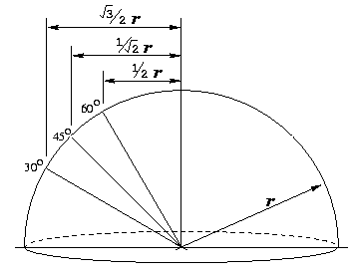

**Construction of hemispherical or elliptical parachutes is more complex as the multiple gores need to be accurately sewn together if anything close to the desired canopy shape is to be produced, and the shroud lines need to be included in the joins between the gores.**

**The fact that multiple gores are required opens up the option of multiple colours in the assembled parachute. Depending on what colours are available in your chosen material, you could select alternating bright fluorescent colours, our national colours, the colours of your favourite football team or whatever takes your fancy. Keep in mind though that brighter and contrasting colours are easier to see. For bungee use avoid greys, greens and browns as these are the traditional camouflage colours and even if the parachute descends onto the field it still could be difficult to locate. This is not necessarily an issue for winch line parachutes as these are usually wound down into the turnaround. However visibility for winch line parachutes could be an issue if there is a line break and your parachute goes drifting off downwind and lands some distance away.**

**Similar to the parasheet type parachute, the rings at the top and bottom can be included when constructing the parachute and it is theoretically possible to use a continuous single length of shroud line, but this can be quite tricky to actually achieve.**

**I used fluoro coloured builders line as the shroud line material in an eight gore parachute. I used eight separate lengths of line for the shroud and then after having put them through the upper and lower rings, stitched and CA'd them together. More elegant methods exist no doubt. Also after many hours of exposure to the sun the fluoro colour in the shrouds has faded significantly.**

**I have made both a hemispherical and a 0.7 ratio elliptical parachute. I find that both deploy reliably and track straight towards the turnaround on wind down. The weight saving achieved by using the elliptical design was only 3g. So the weight saving is real, but quite small.**

**Some pilots prefer to have no metal rings in their parachute due to the risk of model damage should the parachute actually get struck by the aircraft on a steep zoom overrun.**

***Parachute Stability:***

**Parachute stability is enhanced if the shroud lines are made longer below the canopy and conversely stability is reduced if they are shortened. A good starting point for shroud line length is for the shroud length below the lower perimeter of the canopy to be at least equal to the diameter of the deployed parachute canopy.**

**Stability is also noticeably enhanced if a hole is provided in the top of the parachute canopy. Of course too large a hole will reduce the drag to a low level negating the purpose of having the parachute in the first place.**

**Both my hemispherical and a 0.7 ratio elliptical parachutes have holes approximately 50mm in diameter at the top. This seems to work well.**

**With parachutes used on bungees, care should be taken to minimise the weight of any hardware installed above the canopy. As the bungee parachute descends with virtually no line tension, any heavy items on top of the parachute, such as a heavy tow hook ring, will tend to tip the parachute to an inverted position, collapsing the canopy.**

**(5) Technical Aspects:**

# Parachute Equations

# MCj02503980000[1]

## 

## Parachute Diameter Calculation

**The first several seconds after a parachutist jumps from an airplane before opening the parachute, he or she falls freely through thin air with an increasing vertical speed (v) at an acceleration rate equal to the gravity acceleration (g).**

**However as the speed increase, the air resistance or drag force increases squarely with it as in the following equation:**

**Fd = ½  Cd A v2**

**Where:**

**Fd is the drag force   
❒ (Greek letter "rho") is the density of air at current altitude   
Cd is the drag coefficient which is dependent on the chute shape  
A is the area of the chute  
v is the velocity through the air**

**and the net acceleration (a) becomes less and less until some velocity at which a becomes 0 when the acceleration force due to gravity (Fg) becomes equal to the deceleration force due to air drag Fd,**

**Fg = Fd  
m g = ½  Cd A v2**

**where m is the total mass of the chute and parachutist and  
 g is the gravity acceleration of Earth.**

**now solving this equation for the area of the chute:**

**A = (2 m g) / ( Cd v2)**

**given the area of a hemisphere chute is A =  D2 / 4, the chute diameter is calculated as follows:**

**D = sqrt(4 A / )**

**and substituting the right-side of A equation into the equation of D gives:**

**D = sqrt( (8 m g) / (  Cd v2) )**

**Where:**

**D is the chute diameter in meters**

**m is the mass of both the chute and parachutist in kilograms**

**g is the acceleration of gravity = 9.81 m/s2   
❐ (Greek letter "pi") is the constant ratio = 3.14159265359**

** (Greek letter "rho") is the density of air at 0 altitude = 1.225 kg/m3   
Cd is the drag coefficient of the chute =1.5 for a hemisphere chute**

**v is a safe impact speed with the ground (~3 m/s or less)**

**This first equation will be used for calculating the diameter of a hemisphere parachute given the desired impact speed with the ground [input v 🡪 output D].**

## 

## Calculating Parachute Velocity

**Note that we can easily find the descent velocity, given the chute diameter, by simply rearranging the above equation to get**

**v = sqrt( (8 m g) / (  Cd D2) )**

**where:**

**v is a the current descend speed at current altitude**

**m is the mass of both the chute and parachutist in kilograms**

**g is the acceleration of gravity = 9.81 m/s2   
❐ (Greek letter "pi") is the constant ratio = 3.14159265359**

** (Greek letter "rho") is the density of air at current altitude.  
A table of air density at different altitudes is given below.**

**Cd is the drag coefficient of the chute = 1.5 for a hemisphere chute.**

**D is the chute diameter in meters**

**This second equation will be used for calculating the velocity at any altitude with a given air density and the chute diameter [input D,  🡪 output v].**

**Calculating Parachute Altitude**

**Now that we know the descent velocity (v0, v1, v2, …, vn ) at every point in time assuming 1 second interval T (t0, t1, t2, …, tn ), we can find the current altitude (h2) by first finding out how far has the parachute traveled over each time interval (Δh), and subtracting it from the last altitude (h1).**

Δh = h2 - h1

Δh = average(v) / Δt

h2 - h1 = ((v2 + v1) / 2) / (t2 - t1)

h2 - h1 = ((v2 + v1) / 2) / T

thus

**h2 = h1 + ((v2 + v1) / 2) / T**

where:

t1 and t2 are the beginning time and end time of an interval T,  
v1 and v2 be the beginning velocity and end velocity of T  
h1 and h2 be the beginning altitude and end altitude of T.

This third equation will be used alternating with the second equation (i.e. Eq2, Eq3, Eq2, Eq3, Eq2, Eq3, …) for calculating the altitude at each time point.

**Examples of freefall and non-freefall calculations:**

If h1 is 4000m, and v1 is 0m/s then after 1s of freefall acceleration a = -9.8m/s2:

a = (v2 - v1) / T

v2 = a . T + v1

v2 = -9.8 * 1 + 0

v2 = -9.8 m/s

h2 = h1 + ( (v2 + v1)/2 ) / T

h2 = 4000 + ((-9.8 + 0)/2) / 1

h2 = 4000 + (-4.9)

h2 = 3995.5 m

If however h1 is 1000m and the parachute is deployed (i.e. open), then based on air density at this altitude,

the parachute diameter and the total mass of person & parachute, let say we get a speed v1 = -6m/s, thus from the second equation and after 1sec of descend at a near constant speed of -6m/s we drop to altitude h2:

**assume a is -0.1 m/s2**

**v2 = a . T + v1**

**v2 = (-0.1 * 1) + 6**

**v2 = -5.9 m/s**

**h2 = h1 + ( (v2 + v1)/2 ) / T**

**h2 = 1000 + ((-6 + -5.9)/2) / 1 h2 = 1000 + (-5.95)**

**h2 = 994**

**(6) LAYOUT:**

**Parachute Considerations**

**Before examining the geometry associated with flat parachutes, the first question that needs to be answered is - How big of a parachute do I need? The rate of descent will be dependent on the area of the parachute; once we know the required minimum area, a little geometry will tell us the diameter (size) we need to make the parachute.**

**In his book, “Model Rocket Design and Construction”, 2nd Edition, Tim Van Milligan (Apogee Components) provides a useful formula for calculating the minimum parachute area needed for a safe descent speed for a given model rocket mass. The formula is given as:**



**Where:**

**g= the acceleration due to gravity, 9.81 m/s2 at sea level**

**m = the mass of the rocket (propellant consumed)**

**= the density of air at sea level (1225 g/m3)**

**Cd= the coefficient of drag of the parachute – estimated to be 0.75 for a round canopy**

**V = the descent velocity of the rocket, 11 to 14 ft/s (3.35 m/s to 4.26 m/s) being considered a safe descent speed.**

**With this descent rate equation, and a good calculator, one can readily find the needed minimum parachute area for a particular model or mission. To determine its size (diameter), we must generate an expression that relates area to size, and we must take into consideration the shape we choose for the parachute, as shape and diameter will dictate available surface area.**

**Parachute Geometry**

**Let’s inscribe an n-sided polygon inside a circle. As an inscribed polygon, its vertices will be tangent to the circle, and the distance from its center to any vertex will be r, the radius of the circle. Figure 3-1 illustrates what an inscribed polygon looks like; in this case we have chosen to inscribe a regular octagon inside the circle.**



## Figure : Inscribed Polygon

**In this illustration two lines are shown, each originating from the center of the circle and extending to a vertex; together they form an isosceles triangle, the triangle having two identical sides r and a base the length of the polygons’ side. If similar lines were drawn to each remaining vertex, we would readily see that the octagon is made up of 8 identical isosceles triangles. We can extend this principle generally and say that an n-sided polygon is made up of n identical triangles, each triangle corresponding to one of the polygons’ sides.**

**We can also see that the area of the polygon is just the sum of the areas of the triangles that comprise it; here, in the case of this particular polygon, its area is equal to 8 times the area of one triangle, or:**

**AO= 8AT , where AT is the area of the triangle and AO is the area of the octagon.**

**Generalizing for any n-sided polygon, our expression for area is:**

**AP = nAT**

**With this concept now established, a little geometry will permit us to calculate the dimensions of our parachute. To do this, we simply need to establish the area of the elemental triangle that makes up the polygon, and then use the relationship above to calculate the total area.**

**Let’s extract this triangle from the polygon and take a closer look at it:**



## Figure : The Elemental Triangle

**We know that the area of this triangle is:**



**We will now manipulate this relationship so that it can be expressed entirely in terms of r. To do this, we will use some trigonometry.**

**As reasoned earlier, an n-sided polygon is made up of n identical, elemental triangles. The angle subtended at the triangle’s apex is  since there are n triangles making up the polygon, the value of  must be 360/n. For our purposes, we are interested in the angle between r and h; since this is half of  remember, we are dealing with an isosceles triangle), its value must be 360/2n, or 180/n once reduced.**

**We can derive the following expressions from the characteristics of the triangle:**

**; **

**and**

**; **

**Recalling that the area of the triangle is , we can then make the substitutions for s and h and get:**



**There is a trigonometric identity that can be used to further reduce this expression, as follows:**

**For an angle , **

**Here, if we set , then **

**Applying this identity to our expression for, we get:**



**Substitute this result into our expression for , and the area of our n-sided polygon becomes**



**We now have a general expression in terms of the radius, r, which we can use to calculate the area of any n-sided polygon.**

**Typically, we measure the diameter of a parachute as opposed to its radius, so with a little more algebra, we can transform the result into one expressed in terms of diameter.**

**Recall that , where d is the diameter of the parachute/circle:**

**Then **

**For practical purposes, we would calculate the required parachute area for a particular model from the descent rate equation. Once we know the area, we can use the expression from above to determine the required diameter, depending on the type of the parachute we intend to make (hexagonal, octagonal, or other).**

**Rearranging our equation, we can solve for d:**



**We can complete the exercise definitively by substituting the descent rate equation for parachute area in the place of AP; then we get:**



**Let’s work out some practical examples. For a hexagonal parachute, we know .**

**So plugging 6 in for n, we get:**



**For an octagonal parachute, we know n=8:**



**Why should it make sense for the coefficient (the multiplier) of the parachute area to be smaller for an octagon? Well, if we recall Figure 3-1, it can be readily seen that the area of an octagon will be larger (cover more of the circle) than that of a hexagon for the same radius. So to arrive at the same parachute area, the diameter of a hexagonal parachute will need to be larger than that of an octagonal one.**

**The following summarizes the findings of this analysis:**

**Minimum Parachute Area for a Given Model**



**(Reference “Model Rocket Design and Construction”, 2nd Edition, Tim Van Milligan (Apogee Components)).**

**Diameter of a Parachute, given its Area**



**For a Hexagonal parachute, **

**For an Octagonal parachute, **

**Area of a Parachute, given its Diameter**

**; n = the number of sides of the parachute.**

**For a Hexagonal parachute, **

**For an Octagonal parachute, **

**Area of a Parachute, given the length of a Side**

**; s = the length of a side.**

**For a Hexagonal parachute, **

**For an Octagonal parachute, **

**Area of a Parachute, given the distance between opposite sides**

**; D = the distance between adjacent sides, and n must be even.**

**For a Hexagonal parachute, **

**For an Octagonal parachute, **

**The calculation of 18 ft/ave. drop time results were as follows:**

**Square shape parachute dropped at 4.63 ft/sec; Rectangle at 4.70 ft/sec; Triangle at 5.36 ft/sec; Circle at 5.70 ft/sec; Ellipse at 6.00 ft/sec; Control weight alone at 21.18 ft/sec. The results show that the Square shaped parachute decreased the rate of fall of the weight the best and the ellipse para chute the worst.**

**(7) Physical Evidence:**

**Model Parachute**

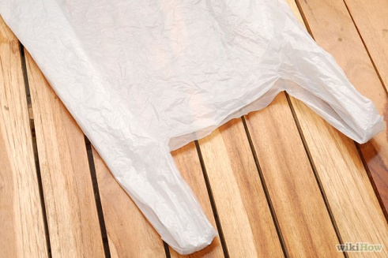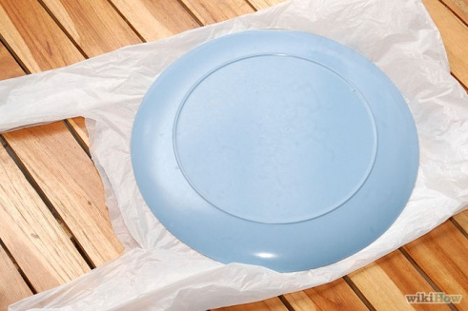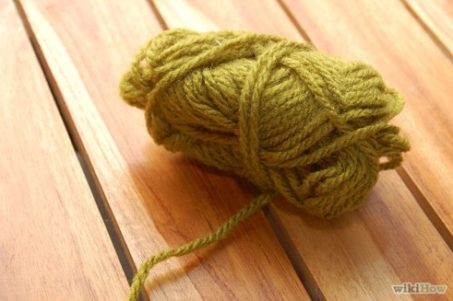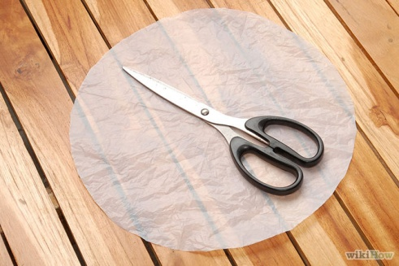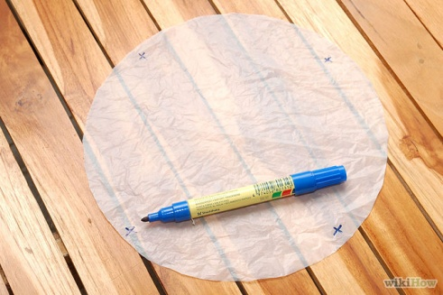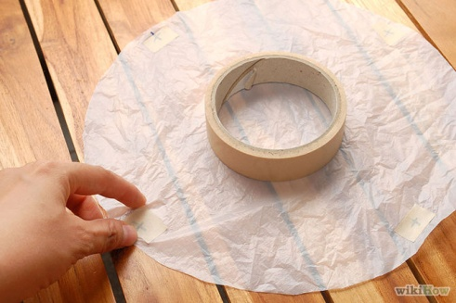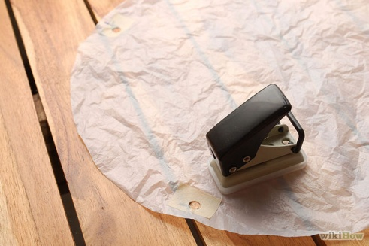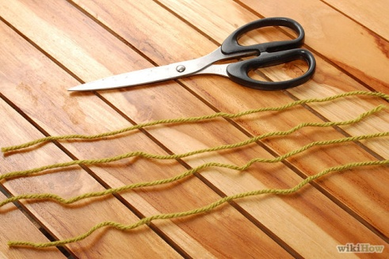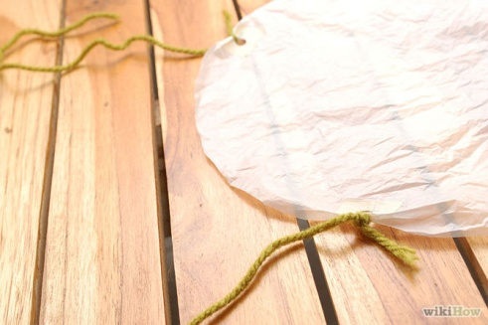

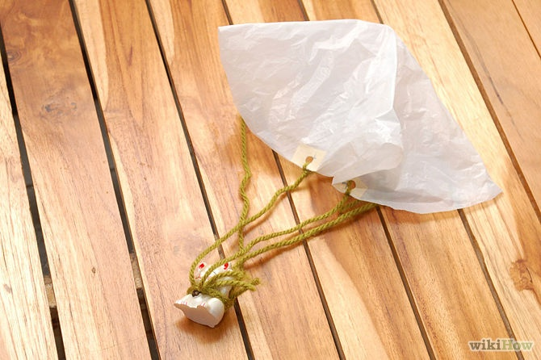

**(8) Conclusion :**

**My experiment proved that the square shaped parachute decreased the rate of fall the best. My hypothesis that the circle shape parachute would fall the slowest was wrong. I believe the square shape was slowest because it has sharp corners and straight edges. This is probably a less aerodynamic shape and so it did not travel through the air as quickly.**